WHAT IS GROUND-SOURCE HEATING?
Ground-source heating relies on the virtually infinite supply of heat in the ground beneath us.
Our planet is a massive heat storage unit. It absorbs almost half the light that reaches it from the sun. Combined with heat from our planet’s own geological activity, the sun makes the Earth itself a limitless, renewable source of heat energy. This energy is known as geothermal energy.
For many people, the term “geothermal” probably brings to mind images of geysers and volcanoes – spectacular displays of extreme heat from within the Earth. Such energy, while powerful, can be harnessed only in geologically active areas.

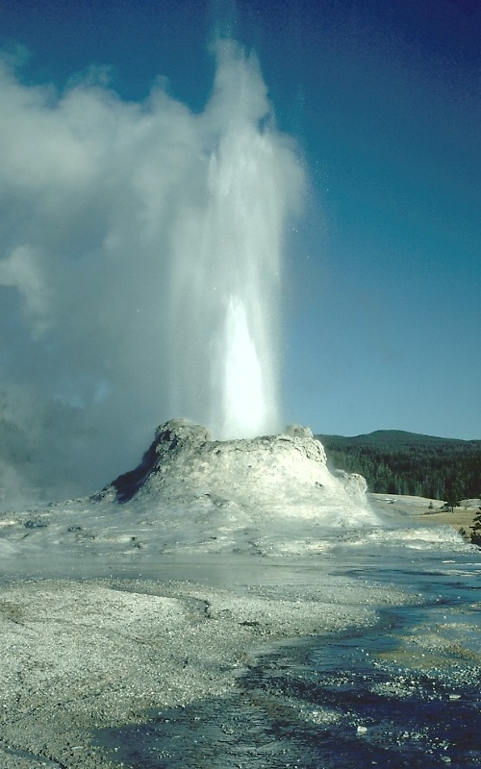

Ground-source heating makes use of the heat available everywhere in the world, just a short distance – often only a few feet -- underground. Temperatures there remain, if not balmy, at least constant – often in the range of fifty to sixty degrees Fahrenheit, depending on the region.

TO LEARN MORE
Ground-source heating is one of many alternative energy sources. As technology advances, it becomes increasingly possible – and practical – to harness the energy around us in new, inexpensive, efficient, and environmentally-friendly ways.
For more information about ground-source heating, and NYSEG’s Geothermal Partnership Initiative (GPI) program, visit our web site at www.nyseg.com.

NYSEG is a subsidiary of Energy East Corporation, a super-regional energy services and delivery company in the Northeast.
NYSEG is a trademark and service mark of New York State Electric & Gas Corporation. Copyright 1995-2002

the energy people you can count on

New York State Electric & Gas Corporation
P.O. Box 5524
Binghamton, NY 13902-5224
Phone 1-800-572-1111

GROUND-SOURCE HEATING

Harnessing the Warmth Beneath Our Feet



sERVING OUR FUTURE energy NEEDS
At NYSEG, we recognize the need for exploring alternative energy sources.
In many parts of the U.S., one of the biggest expenses faced by homeowners is heating. You are probably familiar with the higher energy costs you may incur during the cold winter months. Such costs are the reason behind remedies such as annual budget plans offered by NYSEG and other energy suppliers.



Technological advances and dropping prices are bringing us closer to the day when you may live in comfort without suffering any significant increase in energy costs during the winter months. Ground-source heating can help make this possible.

how does ground-source heating work?
As we have seen, there is an incomprehensibly large supply of heat energy beneath the Earth’s surface. But when the driving snow and freezing winter winds are just outside our door, how do we harness these heat reserves?
The answer lies in heat pump technology. This is the same technology that makes refrigerators and air conditioners possible. Unlike conventional furnaces, heat pumps do not convert energy; they move it.
Heat pumps can remove heat, as with refrigerators and air conditioners, or add heat. By taking a large amount of diffuse energy from a larger area – for instance, a large area of ground under or near a house – heat pumps can concentrate this energy in a different location, resulting in higher temperatures. This is how fifty-degree ground can be tapped to heat a house to any temperature desired in subzero conditions.

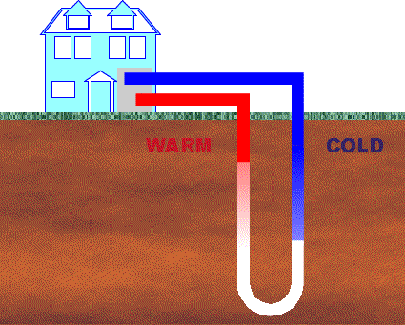

In ground-source heating, some fluid (for instance, a water-antifreeze solution) travels through pipes that loop through the ground and into the building. When the heat is concentrated, it can be distributed throughout the house in any of a number of ways: conventional forced-air, radiant water pipes, or any other familiar method.

ADVANTAGES
- Low Energy Costs: The amount of billable energy used by ground-source heating systems is negligible compared to conventional systems.
- Environmental Safety: Energy savings translates to less pollution. Ground-source heating installations inflict no environmental damage.
- Renewability: The ground is a virtually limitless source of heat.
- Versatility: Heat pumps can cool houses and heat water as well.

DISADVANTAGES
- Initial Costs: Installation may be expensive (although energy savings will compensate). Retrofitting existing buildings may be difficult.
- Heating Delays: Ground-source heating takes longer than conventional systems to bring a building up to a given temperature. But with low energy use, a comfortable temperature can be maintained most of the time.

