Communication 260
Spring 2003
Newsletter/Web Site Project
Brian Hackett – Jae-won Kim – Mike Webb

Manuscript Copies of Articles

Editor's Notes

As spring rolls around and we're finally seeing some serious sunshine here at our corporate offices in central New York, we at Connectrix would like to extend a warm greeting to our customers. And for those of you who may be reading Connectrix Update for the first time, welcome to our community.
This is the second issue of our company newsletter, and we're pleased to say we received a lot of positive feedback after the first issue came out back in January. We'd like to make sure this continues to be a forum for discussion of current company developments relevant to all of our customers, associates, and employees.
This has been a very productive and prosperous year at Connectrix. It's been almost a full year since we launched our newest line of PDAs at the WPDD (World of Portable Digital Devices) trade show in Miami, and we have received a very enthusiastic market response. In March, we doubled our production capacity by expanding into two entirely new facilities, and the demand has certainly been keeping up.
There is definitely a lot of current development going on in both Connectrix and the industry as a whole. In this issue, we take a look at some of these developments, such as Connectrix's new Scribble handwriting recognition system, and our new Digi-Pen system for easy communication among people with Connectrix PDAs. You can also find out more about the ergonomic considerations that have gone into the design of our newest PDA keyboards and other peripherals.
These are exciting times in the development of portable digital devices. We're in the middle of a true revolution in how people communicate and stay organized, and it will be interesting to see which direction the technology will take us next.

Mike Webb, Editor-in-Chief

Behind the New Scribble System
By Brian Hackett

Until now, Connectrix PDAs and, indeed, all other PDAs have been unable to recognize natural handwriting. The Graffiti system of recognition relies on users entering individual letters in a highly stylized fashion. For example, each 'k' must be written like '<,' and none of the 'i's or 'j's are dotted. To people unused to writing using a PDA, this is unintuitive, and entering a few sentences can become a laborious process at first. The Scribble system is a true handwriting recognition tool. It lets you write anywhere on the PDA's screen, and it will interpret and digitize the text within seconds. This increased flexibility makes Scribble invaluable for note taking, or any situation involving a lot of writing. Many of the advances made by Scribbler are made possible by the newest generation of more powerful PDAs, but what really makes Scribble work so much better than Graffiti? To answer this, we asked some researchers at Connectrix about the fundamental differences between the two systems.

Graffiti
Graffiti was developed in 1993 by Palm, Inc. as a simple recognition system that makes minimal demands on the PDA's resources. PDAs which use Graffiti have a small area at the bottom of the screen for entering letters. Letters have one stroke each – one continuous movement of the stylus – and are entered one at a time by repeatedly making the strokes in this area. The Graffiti software works by looking for patterns in the entered stroke: an 'i' is just a vertical line, while a 'j' is curled at the bottom. When you enter a letter into the PDA using Graffiti, it compares your letter to the many 'prototype' letters stored by the PDA. The prototype which most resembles your character is selected and printed on the screen.
The process of determining which prototype your letter resembles is called 'fuzzy logic.' Each prototype is graded based on how many of its basic features – corners, lines, or curves – are included in your letter. The prototype with the most features in common with your letter is selected; not all the features need to be present, hence the name 'fuzzy logic.' Graffiti is very good at recognizing single letters entered in a specific fashion, but with more powerful PDAs we can now build systems which recognize entire handwritten words. Scribble is the first of these systems, giving unparalleled flexibility in writing text using your PDA.
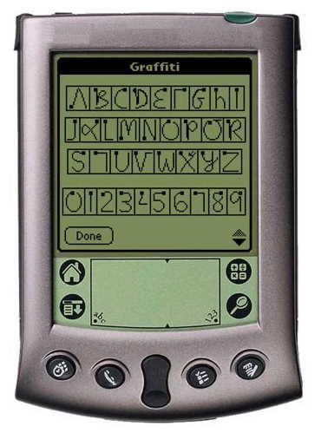
Scribble
There are several problems with Graffiti that make it impractical for use on natural handwriting. It only processes one stroke at a time, preventing it from understanding words where a single stroke is used for multiple letters, as with cursive handwriting, or single letters where multiple strokes are used for the same letter, as with many english letters like 'k' and 'r' (recent versions of Graffiti have corrected the second problem). Its fuzzy logic approach limits it to only a small set of prototypes: if you want to enter a capital letter, you have to enter a special stroke first, akin to pressing the shift key on a keyboard.
Scribble recognizes handwriting in a very different fashion, and this allows it to process entire words written by anyone in either cursive or print. It uses what is called a 'neural network,' a piece of software which has been trained to find words in print and cursive handwriting. Neural networks have been used successfully by Artificial Intelligence researchers for decades, and are very good at finding patterns in different types of data. They have been used to identify objects, recognize faces, and even drive cars around on highways (with someone in the driver's seat at all times, of course, ready to take over if necessary). These types of tasks are very easy for us to do, since our eyes have adapted to automatically organize our visual information. Neural networks emulate this ability by approximating the behavior of the neurons which make up our visual systems. One of the most important things our eyes do is allow us to quickly read letters and words, as long as they're in a particular area of our visual field (To see this in action, try reading a line of text with your eyes focused a few inches away on the page. You should be able to see the words, but you won't be able to read them). It is only natural, then, to build a system which uses a neural network to read and digitize handwriting.
The neural network used by Scribble simulates the behavior of several thousand neurons, and the strength of the connection between each pair of neurons determines how good the network is at recognizing different words. After setting up the network to guess randomly after seeing a word, it was trained by being fed hundreds of thousands of writing samples. For each sample, the network makes its best guess about what word was written. If it chooses wrong, the neuron connections are calibrated, changed so that similar words will be recognized correctly in the future. After seeing the same words hundreds of times, the network becomes very good at distinguishing them. The neural network in Scribble can easily identify thousands of common words, and it is very good at recognizing ones it has never seen before. It can even learn from its particular user, gradually getting better and better at reading their handwriting quickly and accurately. Scribble is the first handwriting recognition system to work on a PDA, and presents a dramatic improvement in the ease of use of Connectrix PDAs.
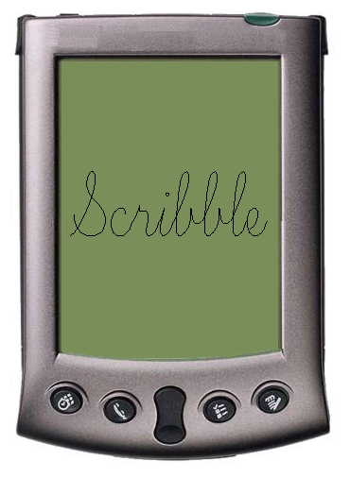

Wave of PDA Digital Signature Solutions
By Jae-won Kim

Several digital signature solutions are being released for PDAs.
Industry sources announced on April 27, 2003, that Connectrix, Pidian Hi-Tech, Mizi Research, MMi Group, and ToBe Tech are about to release commercial digital signature products, determined that PDA digital signatures will be widely used in e-commerce and corporate infrastructure access.
Connectrix's Cyber Sign stores the bio-characteristics of individual signatures made on screens of PDAs, Web Pads, e-Books and Web Phones using vector compression technology. This makes files 15 times smaller than regular image files, and an average signature data file is only about 230 bytes. In addition, Cyber Sign was designed to read, store, and transmit signatures made on any touch sensor device, without separate hardware.
Steven Baker, a director of Pidian Hi-Tech Co., Ltd., said that they had developed a digital signature engine some time ago. However, lack of demand prevented them from actively marketing the product. They expect an expanded market starting next year and plan to release a commercial version of Cyber Sign in October to lead the market.
Mizi Research has a strategy of linking sales of its digital signature solution 'Sign Wise' with Linuette, an embedded version of Linux developed by Mizi. Mizi explained that Sign Wise supports Java and Active X, facilitating the implementation of signature verification systems on the web. Furthermore, since it examines not only the signature shape, but also speed and pressure change values, more accurate signature comparison is possible, the company added.
MMi Group has developed 'SignQ,' which provides a 7-level security configuration. Its signature data is 1kb per person and the engine size is a mere 8kb (32kb for Windows, 6kb for Java).
ToBe Tech has also developed its digital signature solution, PDA Sign, and the company plans to release a commercial version next month. It looks like the competition will be fierce to take the leading position in the digital signature market.

Digi-Pen: Pen Computing Solution
By Jae-won Kim
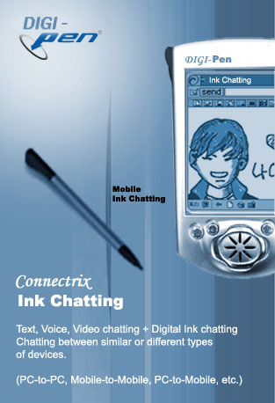
Digi-Pen is a new-concept communication solution that Connectrix developed, based on Connectrix's Digi-Ink technology, for sharing visual information. Digi-Pen transfers or shares information, which is difficult to display with traditional communication methods, with minimal amount of data transmission required. In order to explain Digi-Pen, we first have to understand what Digi-Ink technology is.

Digi-Ink
Digi-Ink is a group of coordinated data drawn from the pen traces made on a touch-screen. It displays a character written or a picture drawn by a user like an image file, so it can enables diverse displays that can not be portrayed with simple text. There is a significant difference between regular image files and Connectrix's Digi-Ink in terms of data storage. Whereas any regular image file saves all pixel information and displays the image by rearranging it, Digi-Ink only stores the coordinates and the order of the pen trajectory. Therefore, the data size is substantially smaller than that of an image file.
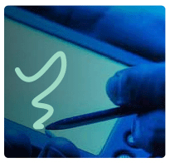
The principle of Digi-Ink was released in the early 90s, and it has been mainly used for memo-writing solutions. However, with the recent adventages of wireless PDAs, Digi-Ink is coming up as a new solution for mobile communication. Its small data requirement facilitates application in relatively slow wireless networks, and its pen writing mechanism is satisfactory for the wireless device environment. Moreover, it features easy editing in stroke units, active data displays and easy links to voice and video mail.
Connectrix utilized this Digi-Ink technology in wireless PDAs and PCs, as well as existing services including chatting and e-mail. With these advantages, Digi-Ink is providing new business models for wireless service providers who are looking for new core services to wireless Internet users. And Digi-Pen now provides Connectrix Messenger, Chatting, and Mail features:

- Connectrix Ink Messenger
Connectrix Ink Messenger synchronizes messages between PC and PDA. It provides Digi-Ink editing for creating Digi-Ink messages (editing in stroke units), as well as providing general text messages. It also has animation capability which draws the received Digi-Ink message in the order that it was created. Its compatible devices are PDA, SmartPhone, PC, and Internet Phone.
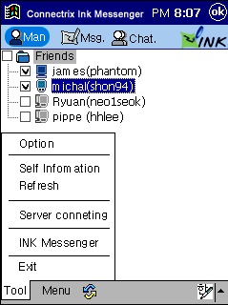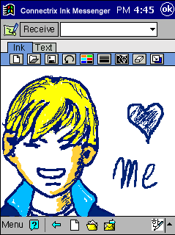
Connectrix Ink Messenger (PDA)

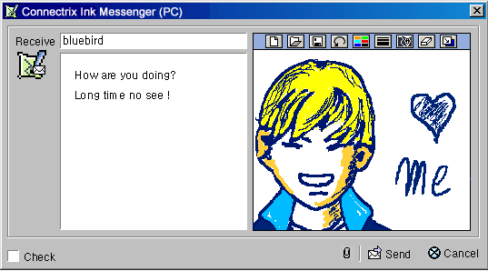
Connectrix Ink Messenger (PC)

- Connectrix Ink Chatting
Connectrix Ink Chatting allows chatting (1:1 and multiple chatting sessions) between similar or different types of devices: PC-to-PC, Mobile-to-Mobile, PC-to-Mobile, etc. It provides Digi-Ink editing for creating Digi-Ink messages, as well as supporting Text, Voice, Video chatting + Digi-Ink Chatting. All these Text, Digi-Ink, Voice, and Video chatting can be used simultaneously in a chatting session. Above all, Connectrix Ink Chatting’s the significance is that it has 30 times greater compression than regular images (very little data traffic required).
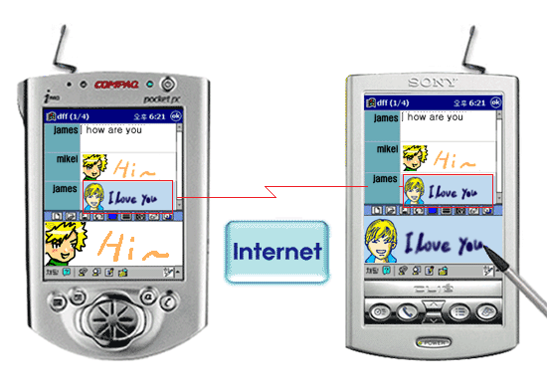
Connectrix Ink Chatting (PDA to PDA)

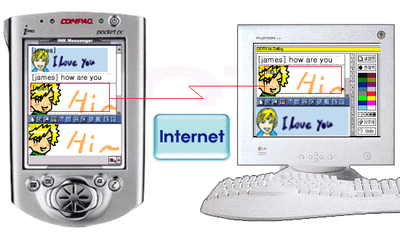
Connectrix Ink Chatting (PDA to PC)

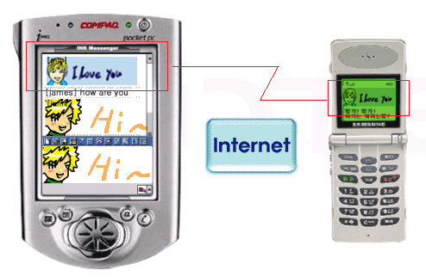
Connectrix Ink Chatting (PDA to Phone)

- Connectrix Ink Mail
All of Connectrix Ink Mail's functions are provided in general text-based mail services which can also be linked to voice and video mail. As with other Ink Messenger and Chatting systems, Ink Mail provides Digi-Ink editing for creating Digi-Ink Mail (editing in storke units), and its animation capability draws the received Digi-Ink message in the order that it was created. However, in case recipient's mail service doesn't support Digi-Ink format, the Digi-Ink document is converted into an image.
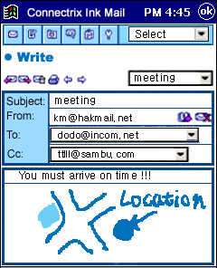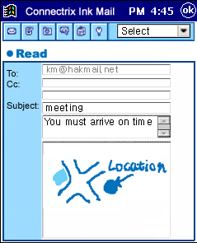
With Connectrix Digi-Pen's services distinguished from other companies traditional PDA solutions, it will enrich PDA data services among different types of devices (PDAs, cellular phones, PCs, eBooks, etc).

Tips on Scheduling Events With LifeSynch
By Brian Hackett

Keeping track of schedules is perhaps the most common thing that Connectrix PDAs are used for. The LifeSynch software makes it quick and easy to schedule individual events, but few people know about its more advanced features. You can set up recurring events, which are entered into your schedule at periodic intervals, you can link your schedule to files stored on your PDA, and you can even set up the PDA to alert you about a scheduled event at any time you specify.

Scheduling Recurring Events
Many people find themselves scheduling the same thing over and over again, whether it be a weekly meeting or an annual holiday or birthday. Recurring events can be set up to automatically enter your schedule at specified intervals. Scheduling a recurring event works differently from the normal scheduling procedure. Instead of selecting a free spot on the calendar, open 'Events' and then 'Recurring' in the menu accompanying the calendar. From here, select 'Add', and you can now specify whether the event occurs daily, weekly, monthly, or annually, the date when the event should first be scheduled (later times will be filled in automatically), a name and description for the event, and, optionally, the time of day the event occurs at. You can change or remove existing recurring events by going to the same menu, highlighting the event, and selecting either 'Modify' or 'Delete.'

Linking Events to Files
You may often find that it's difficult to include enough information about an event in its description. If you need to get groceries, you want to include the list; if you're holding a meeting, you want the contact information of those who will attend; if you're giving a presentation, you want notes from your slides to help prepare. If you already have a file with this information stored on your PDA, you can easily make a link to it from the appropriate event. First, go into edit mode by double-clicking on the event. Open 'Insert' and then 'Link' in the menu accompanying the event. Now, just browse to the file and select it, and your event will have a link to the file listed below its description. Select the link, and the file will be immediately opened.

Setting up Event Alerts
If an event is particularly important, or it has a fixed time or deadline, it is always a good idea to set up an alert for it. If you set up an alert, at a specified time before the event your PDA will start either vibrating or beeping, much like a pager. To set up an alert for an existing event, go into edit mode by double-clicking on the event. Open 'Insert' and then 'Alert' in the menu accompanying the event. Select a time for how long before the event you want the alert to start, as well as the type of alert (vibrate or beep). Afterwards, the alert will be listed below the event's description. If you want to cancel the alert, just select and delete it.

Digital Rodents: What is this "mouse" all about?
By Mike Webb

Often in the history of technology, a certain device or technique will become so completely ubiquitous that it almost seems as though it has always been around. In the computing industry, we certainly have our fair share of such innovations, many of which most people probably use on a daily (if not hourly) basis. As a maker of input devices (among other things), Connectrix deals in the trade of such technology, as our keyboards and mice represent the link between many people and their computers.
The mouse is an interesting example. At first glance, it may seem like a rather strange object. The idea of moving a small, hand-held object on a desktop to represent -- and control -- the movement of a small arrow on what is ostensibly a TV screen is at the very least abstract. And many people find mice to be an awkward mechanism until they're used to using them, at which point it becomes second nature.
First popularized by the Macintosh in 1984 and Commodore Amiga in 1985, mice are the product of a long history of early research into human-computer interaction. This research is ongoing, and as computers have become more widespread and mainstream over the past two decades, the salience of understanding and assessing user needs and tasks has increased markedly. And yet, since the revolution from text to graphical interfaces began in 1984, mice remain the input device of choice.
This is not for lack of alternatives. There have been for some time -- and probably will continue to be -- dedicated proponents of alternative devices, such as trackballs. A trackball is somewhat of an upside-down mouse, and there are people who find it to be far superior to a mouse, for reasons pertaining to everything from functionality to ergonomic preferences. Similarly, portable computers have brought about the need for other mouse alternatives, such as the trackpad (a small rectangular surface that senses a user's finger strokes). Many people who begin computing life with a mouse find a trackpad to be annoying and difficult to use, and it is very common to see a laptop at a desk with a mouse attached. It would be interesting to speak to people who began with a trackpad and moved to a mouse later, although this is a fairly uncommon phenomenon.
In short, there is a lot of history and research behind even so common and mundane a device as a computer mouse. Tested by time, the technology continues to prove itself eminently useful, and it will be interesting to see if any other input device technology will dethrone the mouse in the foreseeable future.

Using Ergonomics to Design the Butterfly Keyboard
By Brian Hackett

Eighteen months ago, a team at Connectrix set out with the task of developing a compact and comfortable keyboard for use with Connectrix and other companies' PDAs. It was a difficult project, partially because of its requirements on the durability and reliability of the keyboard, but also because of the many considerations regarding the keyboard's ease of use. The team turned to ergonomics, a field of study concerned with how people use machines, and, more importantly, how to improve the machines based on the problems people have with using them.
Ergonomics is a focused science which draws heavily from many disparate fields. One aspect focuses on psychology, on examining peoples' conceptions of machines, so as to understand their intuition about how things should behave. Another important aspect is concerned with how people actually interact with machines. Anthropometry is the study of peoples' physical features, the shape of their hands or body, and is used to design machines that will fit their users, as opposed to machines which require their users to fit them. Anthropometry has played a very important role in the development of computer peripherals and devices, including PDAs. A particularly interesting case is the keyboard, which, despite its central role to human-computer interaction, has only recently come under the lens.
Historically, keyboards have strayed very little from the typewriters which came before them. Ergonomics as a science was not developed until after the second World War, meaning that human factors played a very small role when Christopher Sholes developed the original typewriter in 1873. Instead, mechanical issues were the main concern. We still use the same basic key design, which was chosen to easily facilitate the actions of the bars which swing up to print individual letters. A more egregrious holdover is that of the earliest typewriter's key layout. The 'QWERTY' arrangement was designed to be inconvenient: if two adjacent letters on the keyboard were typed right after another, the typewriter would frequently jam. Putting common pairs of letters far away on the keyboard has the effect of slowing down typists, since common letters are harder to reach. Since then, ergonomic and linguistic principles have never won out over the desire to maintain a constant layout, and keyboards today use the same 'QWERTY' arrangement.
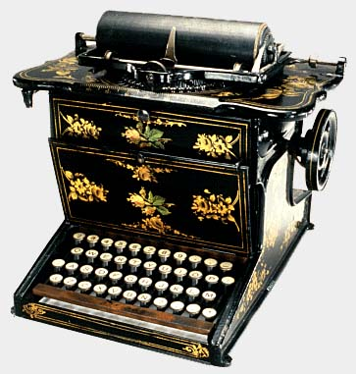
Ergonomics has played an important role in recent improvements to keyboards, however, on both anthropometric and psychological grounds. Anthropometric methods were used to improve the shape of keyboards, giving us a wide variety of 'ergonomic' keyboards. These have usually taken the shape of keyboards with wrist supports or keyboards broken in half, oriented to reduce wrist and hand fatigue. Psychological studies of peoples' interactions with computers have given us new buttons on the top of many keyboards, which allow easy access to the computer's most commonly used features.
Both of these advancements were taken into consideration by the Connectrix team. While a full-sized, ergonomic keyboard is not something that can be folded up and put into a pocket, hinges have been added which allow the keyboard to be tilted at several angles, improving writing speed and comfort levels. As with other modern keyboards, small buttons have been added which open up the common applications found on Connectrix PDAs.
A third ergonomics concern emerged in development of the Butterfly keyboard. Although there is no longer a mechanical motivation behind it, modern keyboards still use the same key-based design for typing in letters. What the Connectrix team found is that people need tactile feedback from the keyboard as they're typing. A touchpad would be very simple to make and use, but since there is no physical indication to the typist that a key has been pressed, more errors result. Full-sized keys are infeasible for a collapsible keyboard, since it must fold up to become as compact as possible. The team solved this dilemma by using a different type of key. A carefully designed rubber covering for the board allows a smaller profile, but still gives an appropriate amount of resistance when keys are pressed. By carefully studying the cues people take in when they write using a keyboard, ergonomics has enabled Connectrix to develop a durable, foldable keyboard that feels just as right and natural as a regular keyboard.

